User Manual
1.5.5

As of 2026-09-20

Table of Contents
1. Introduction 4
2. Functions 4
2.1 Map 4
2.1.1 Map Providers 4
2.1.2 Map Overlays 4
2.1.3 Map Tools 6
2.1.4 Displays 7
2.1.5 Drop zone marker: 7
2.2 Weather Panel 10
2.2.1 Time Slider and Model Selection 10
2.2.2 Mean Wind 11
2.2.3 Upper Air Data 11
2.2.4 Wind Chart 14
2.2.5 Meteogram 14
2.3 Planner Panel 15
2.3.1 Landing Pattern 16
2.3.2 Calculate Jump 17
Show Canopy Flight Area: 19
Show Jump Run Track: 20
Show Exit Area: 22
Show Cut Away Finder: 23
Terrain Clearance: 24
2.3.3 HARP Manager 25
2.3.4 Ensembles 26
2.4 Jumpmaster Panel 29
2.4.1 ADSB Tracker 29
2.4.2 Live Tracking 30
2.4.3 Jump Master Lines 31
2.4.4 Map Orientation 32
2.4.5 Auto Follow 33
2.5 Dashboard 33
2.5.1 Jumper 33
2.5.2 Jumpmaster 35
2.6 Search Panel 36
2.6.1 Locations 36
2.6.2 Dropzones 37
2.7 Settings Panel 38
2.7.1 Units 38
2.7.2 Download Files 38
2.7.3 Export Jump 40
2.7.4 Map Settings 40
2.7.5 Historical Date 41
2.7.6 Import 41
Load Track 42
Load Profile 43
2.7.7 App Management 44
2.7.8 Alerts 45
3. Notes and Warnings 46

Introduction

DZ-Master is an application (iOS and Android, Web) for jump planning based on current weather data from the Open Meteo API. ⁴³
An interactive map with a live tracking function visualizes the approach, exit, canopy flight, landing pattern, and the analysis of the jump. ⁴⁴
This user manual is intended to help you use the full potential of DZ-Master.

Functions

This chapter describes the comprehensive functions of DZ-Master
.

Map

DZ-Master uses the Leaflet library (https://leafletjs.com/) for displaying the interactive map.

Map Providers

Available map backgrounds:

OpenStreetMap | https://www.openstreetmap.org/
OpenTopoMap | https://opentopomap.org
Esri Satellite | https://server.arcgisonline.com/
Esri Street | https://server.arcgisonline.com/
Esri Topo | https://server.arcgisonline.com/
Esri Satellite + OpenStreetMap | Combined Map
OpenFlightMap | https://www.openflightmaps.org

Map Overlays

The map menu offers several additional layers that can be enabled independently of each other. They can be freely combined with one another and with any map background:
Overlay | Description
Weather Radar | Shows the precipitation radar. Transparency and loop playback can be adjusted.
US Airspace (FAA) | Official US airspace.
Worldwide Airspace (openAIP) | Worldwide airspace data.
Open Flight Map | Aeronautical chart layer showing airfields and airspace.
Seamarks (OpenSeaMap) | Nautical seamarks.

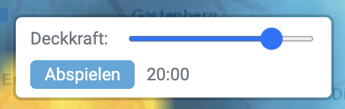

Map Tools

At the top right, you can switch between different map backgrounds (see 2.1.1). You can also zoom in and out using the + and – buttons. If the map is rotated manually, a button appears to reset the map to “North up”.
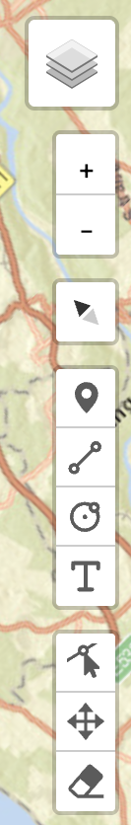
Here you will also find the measuring and drawing tool:

 | Set a point marker on the map
 | Draw a polyline with direction and distance of (partial) segments on the map
 | Draw a circle with radius displayed in km on the map
 | Insert a label on the map
 | Activate edit mode
 | Move drawn elements
 | Remove drawn elements
The drawn elements (point markers, polylines, circles and labels) can be exported as a GPX file, see [Settings] > [Export Jump].

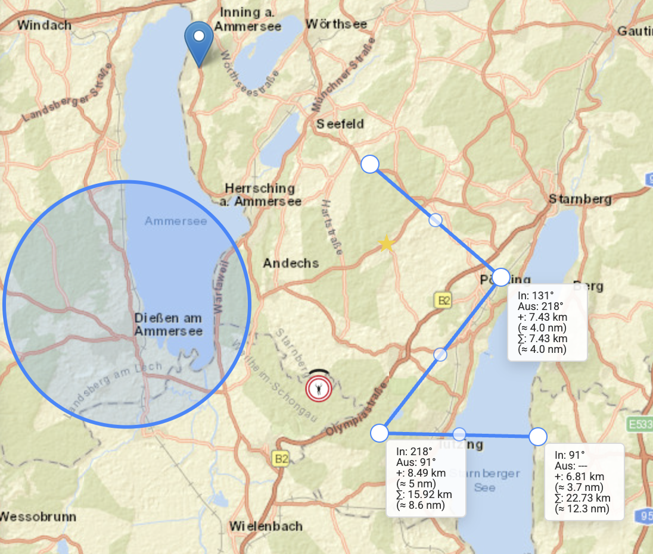

Displays

At the bottom left of the map, there is a length scale and a field displaying the coordinates, altitude, and QFE (only when hovering over a point) of the mouse.

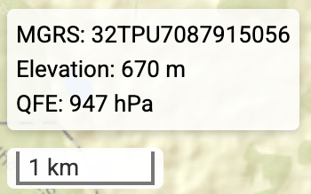

Drop zone marker:

If location sharing is enabled and the device supports location determination, the drop zone marker is set to the current position; otherwise, it is set to a preset position.

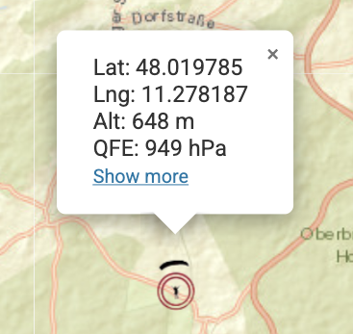
Clicking the marker displays the current coordinate in the format set under [Settings], the terrain elevation, and the QFE for the time set in the time slider.
Clicking „Show more“ shows all available coordinate formats at once
.
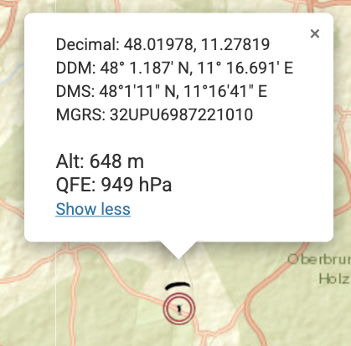
Clicking the marker again deactivates or reactivates the popup with this information.
The marker can be moved to a new position either by right-clicking or drag and drop, or by entering a new position in the [Search Location] menu.

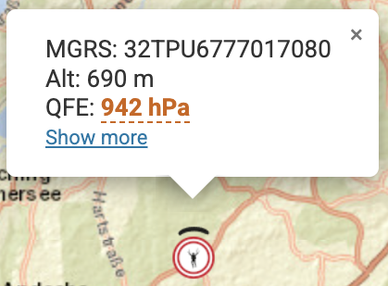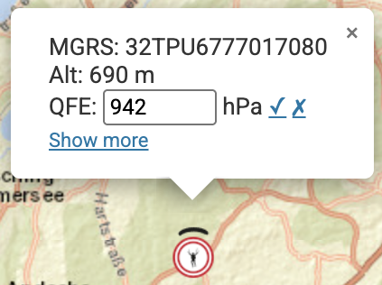

If highly structured terrain is detected at the selected position (elevation differences of at least 150 m within a radius of approx. 6.5 km), the QFE value is shown with a color-coded warning indicating that the QFE calculated by the weather model may be inaccurate there. In this case, the QFE value can be calibrated by tapping it against a measured value: an input field opens where the measured QFE value can be entered and confirmed with “Apply calibration”.
An active calibration is marked with a ⚙ icon next to every QFE display; a tooltip shows the correction offset and the time until which the calibration remains valid. It is valid for a maximum of 6 hours and is automatically cleared once the marker is moved or the validity period expires. The calibration is applied consistently to all QFE displays (drop zone marker, HARP, mouse position on the map).

Weather Panel

The Data Panel visualizes meteorological data.

Time Slider and Model Selection

At the top center, there is an input field where meteorological parameters can be retrieved for a time selected using a time slider and by choosing a weather forecast model.

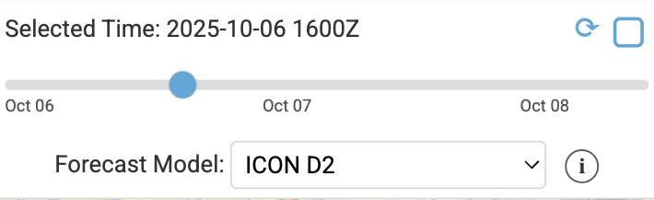
In the dropdown menu, only the models available for the selected point are automatically displayed.
The underlying model run can be accessed via the info button.
If an own profile is loaded (see section “Import” in the Settings Panel), the dropdown additionally contains the entry [★ Own Profile].
You may select from these models:

Model | Resolution | Coverage | Updates | Forecast Period
ICON Seamless | ~2–11 km | Global (combines ICON-D2, ICON-EU and ICON Global) | Every 3–6 hours | 7 days
ICON Global | ~11 km | Global | Every 6 hours | 7 days
ICON-EU | ~7 km | Europe | Every 3 hours | 5 days (120 h)
ICON-D2 | ~2 km | Central Europe (Germany, Switzerland, Austria) | Every 3 hours | 2 days (48 h)
ECMWF-IFS | ~25 km | Global | Every 6 hours | 7 days
ECMWF-AIFS | ~28 km | Global | Every 6 hours | 7 days
GFS Seamless | ~3–13 km | Global (combines GFS and HRRR) | Every 1–6 hours | 7 days
GFS Global | ~25 km | Global | Every 6 hours | 7 days
HRRR (until end of Nov 2026 only) | ~3 km | Contiguous USA (excl. Alaska and Hawaii) | Hourly | 18 h (48 h for the 0, 6, 12 and 18 UTC runs)
RRFS CONUS (successor to HRRR) | ~3 km | Contiguous USA (excl. Alaska and Hawaii) | Every 6 hours | 3.5 days (84 h)
RRFS North America | ~13 km | North America | Every 6 hours | 3.5 days (84 h)
AROME | ~2.5 km | France and neighbouring countries | Every 3 hours | 2 days (48 h)
GEM Regional | ~10 km | North America | Every 6 hours | 3.5 days (84 h)
GEM-HRDPS | ~2.5 km | Canada and northern USA | Every 6 hours | 2 days (48 h)
If you activate the auto-update checkbox (top right), the time is automatically set to the current hour and all calculations are updated.

Mean Wind

In the Data Panel, the mean wind is displayed for a user-defined layer. The lower and upper boundaries of the layer can be set by entering a lower limit and upper limit.

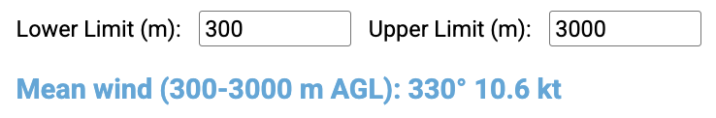

Upper Air Data

The units of the weather table are adjusted according to the settings in the [Settings] menu.
Wind is displayed both as a numerical value for direction and speed, as well as with wind barbs.
The table is color-coded:

Light wind | <= 3 kt
Weak wind | < 3 - 12 kt
Moderate wind | < 12 – 19 kt
Strong wind | > 19 kt

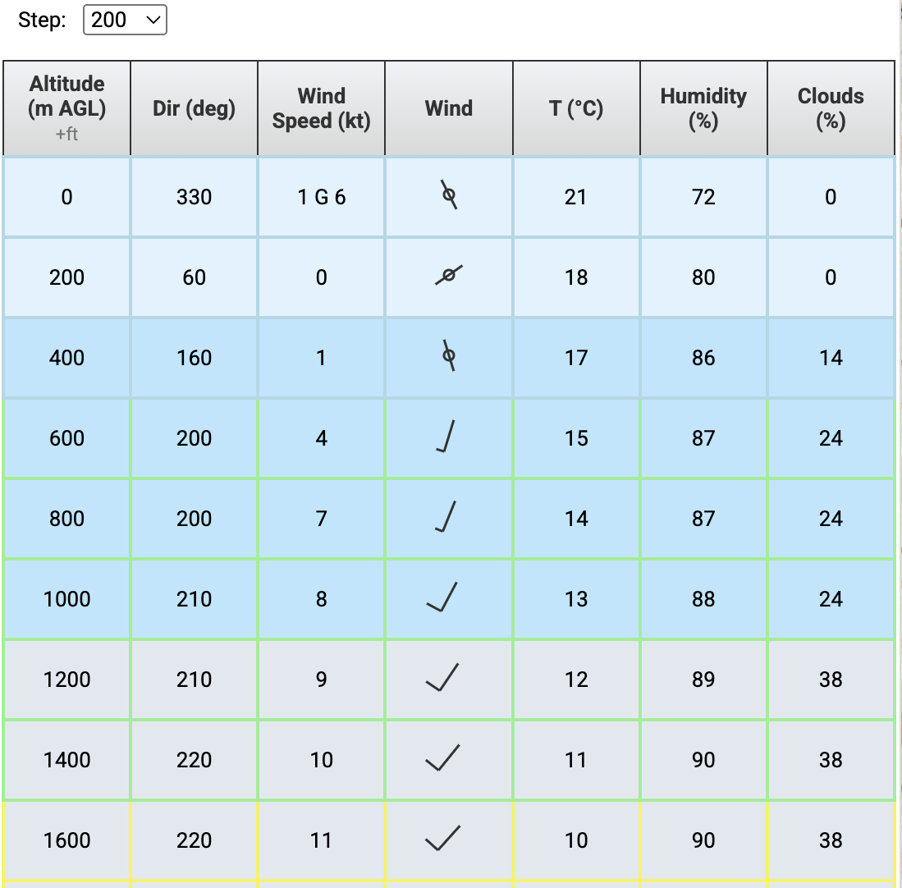

Depending on the cloud cover at the respective altitude, the background color of the table changes to allow conclusions about the cloudiness:
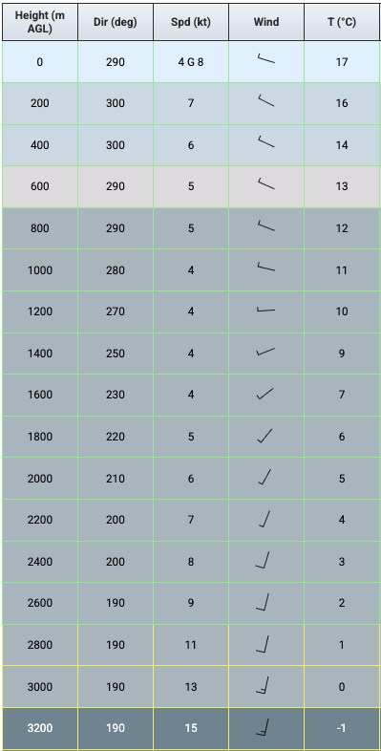

Cloud cover SKC <=10%
10% <= Cloud cover FEW < 25%
25% <= Cloud cover SCT < 50%
50% <= Cloud cover BKN < 87%
87% <= Cloud cover OVC < 100%

The corresponding icon in the table header (+ft), or the “Also show ft AMSL” setting under [Settings] > [Units], can be used to show or hide an additional column with altitude in ft AMSL.

Wind Chart

At the bottom of the Data Panel is the wind chart. It is displayed up to the altitude selected as the upper limit.
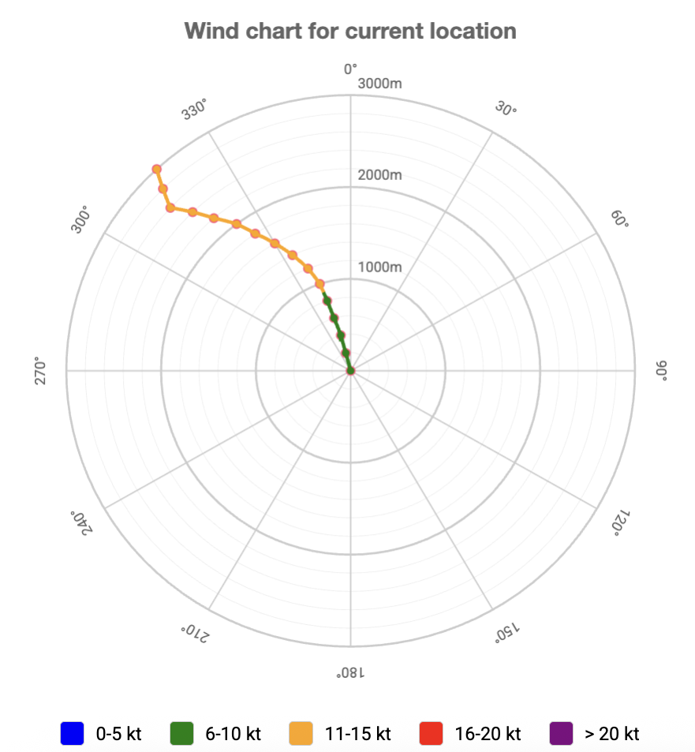

Meteogram

The meteograms for upper air and surface values are located beneath the wind chart.

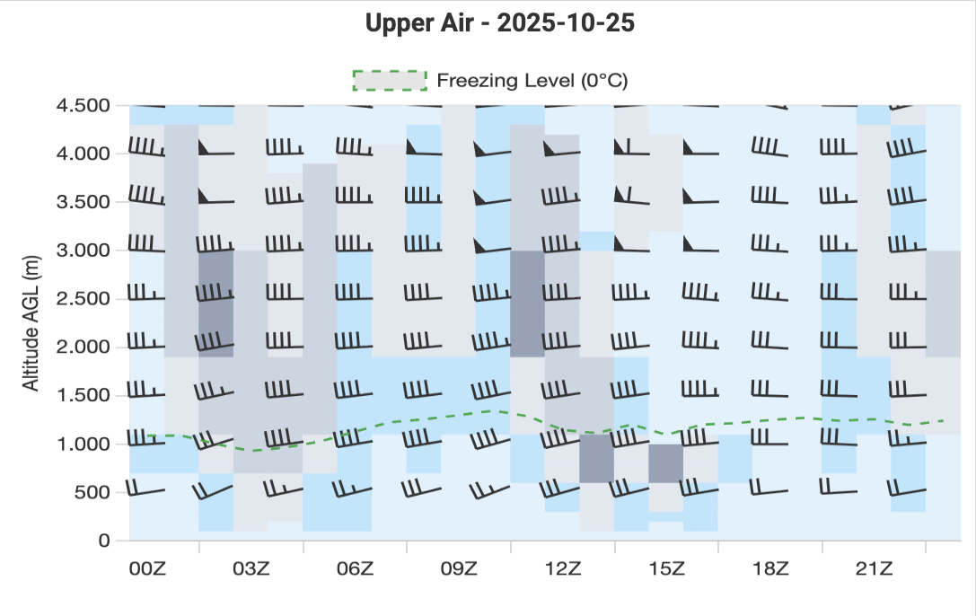
In the upper air meteogram clouds are displayed in different shades of grey as well as wind barbs. The green dashes line shows the freezing level.

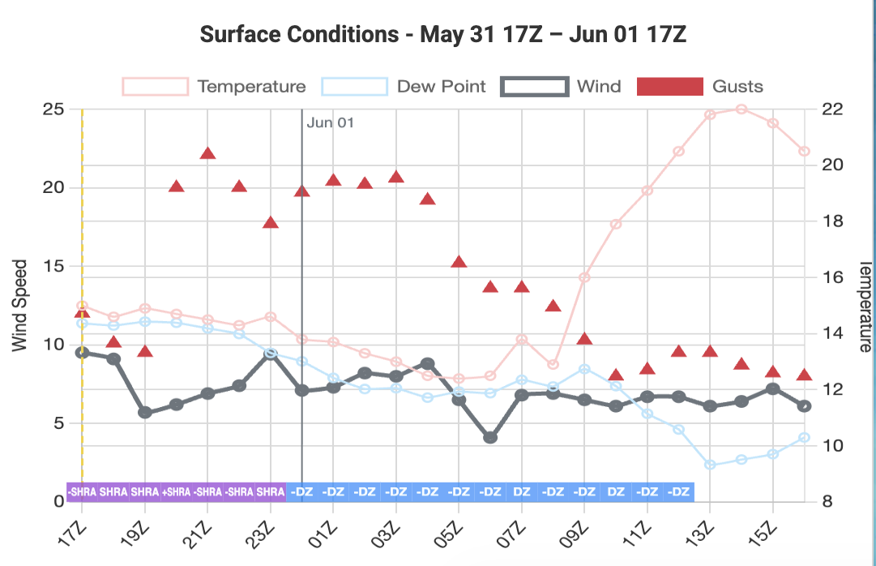

The surface meteogram schows the mean wind and the gusts as well as temperature and dew point and in the lower part the significant weather formatted like in METARs or TAFs.

Planner Panel
All settings for the jump are made in the Planner Panel.

Landing Pattern

The landing pattern is displayed on the map starting from zoom level 14 (500 m on the scale at the bottom left of the map) when the checkbox for [Landing Pattern] is selected in the menu.

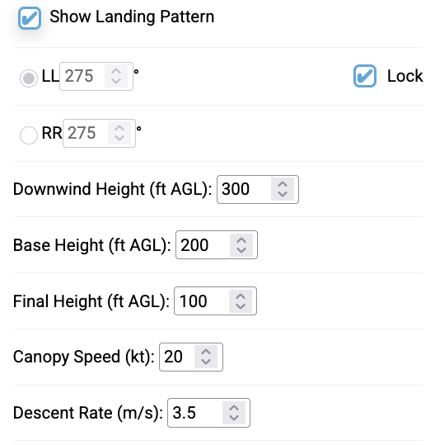
Configuration options in the menu:
- Entry altitudes for each leg of the landing pattern
- Selection of whether a left-left (LL) or right-right (RR) pattern should be flown
- Option to enter user-specific landing directions
- Input of the canopy’s forward speed and sink rate
The default landing direction is based on the surface wind at the landing site, as predicted by the selected weather forecast model for the time of landing. This can be overridden and/or locked by the user. A locked landing direction stays constant even if the surface wind is changing.

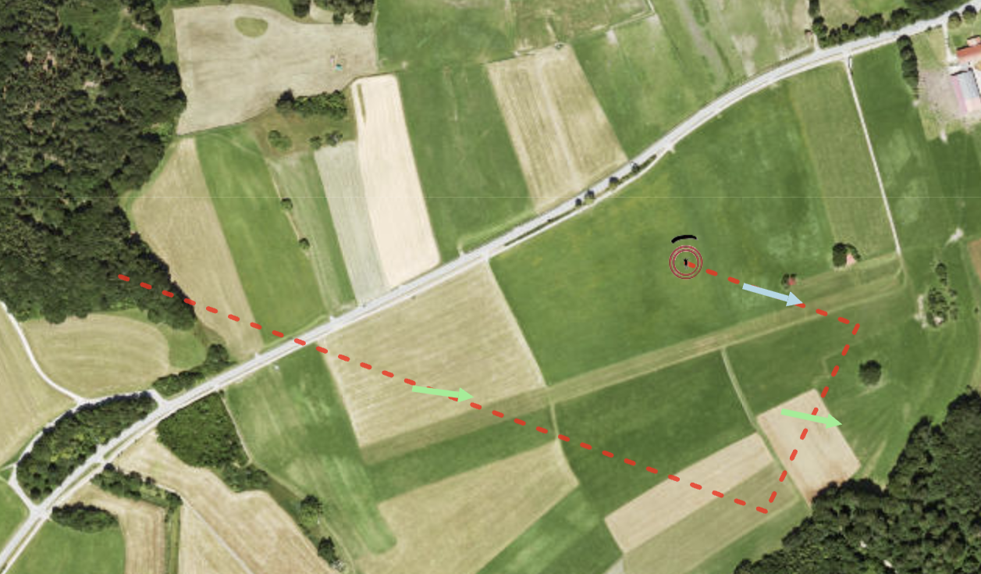 | 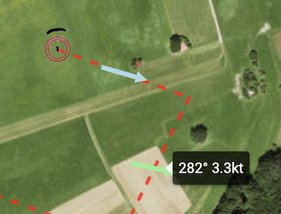

The pattern is represented by a dashed red line. Each leg of the pattern has an arrow indicating the mean wind in that leg. The direction of the arrow shows the wind direction, and the color indicates the speed range as in the wind table.
The exact mean wind in each leg can be viewed by mouse-over.
The pattern is calculated as follows:
For the calculation, the forward speed and sink rate specified in the [Canopy Parameters] menu are used.
The “downwind leg” is oriented exactly opposite to the direction of the final leg.
To calculate the length of the downwind leg, the mean wind between the entry altitude of the downwind leg and the entry altitude of the base leg is determined. Together with the canopy speed and the direction of the downwind leg, this results in the ground speed and thus the length of the downwind leg.
The “base leg” is oriented exactly 90° to the downwind leg. Depending on the pattern direction, 90° to the left for LL or 90° to the right for RR.
To calculate the length of the base leg, the mean wind between the entry altitude of the base leg and the entry altitude of the final leg is determined. Together with the canopy speed and the direction of the base leg, this results in the ground speed and thus the length of the base leg. Since the wind usually comes from the side in the base leg, the base leg does not appear perpendicular to the downwind and final legs on the map, because it is assumed that the jumper maintains the heading (90° to the downwind leg) and is drifted by the wind.
The “final leg” is oriented according to the surface wind, so that landing is exactly against the prevailing surface wind.
To calculate the length of the final leg, the mean wind between the ground and the entry altitude into the final leg is determined. Together with the canopy speed and the direction of the final leg, this results in the ground speed and thus the length of the final leg.
If the user sets an alternative landing direction, the legs are adjusted accordingly and recalculated, taking wind influence into account.
The landing pattern can also be exported as a GPX file, so it can be imported into any other tool (see [Settings] > [Export Jump]).

Calculate Jump

In this submenu, the jump planning takes place.
For the calculation, the forward speed and sink rate specified in the [Landing Pattern] menu are used.
To perform the calculation, you need to enter the Exit Altitude and Opening Altitude, while entering a Safety Height is optional. For the calculation of the Jump Run Track, you also need the Indicated Airspeed (IAS) of the aircraft, the number of jumpers, and the separation interval between the jumpers.
For the separation, the program suggests a value depending on the drop speed, but this can be overridden.

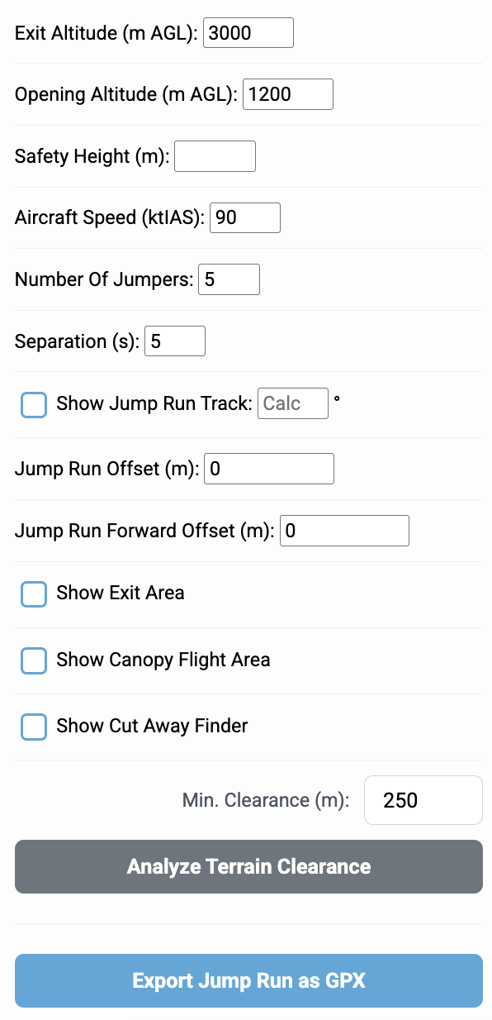

Show Canopy Flight Area:
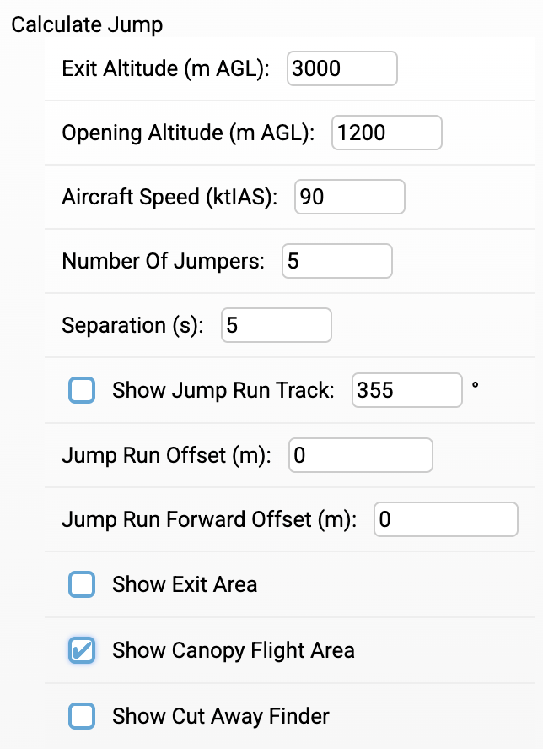
If you activate [Show Canopy Flight Area], a red and several blue circles are displayed for zoom levels 11 (scale 5 km) to 14 (scale 500 m).

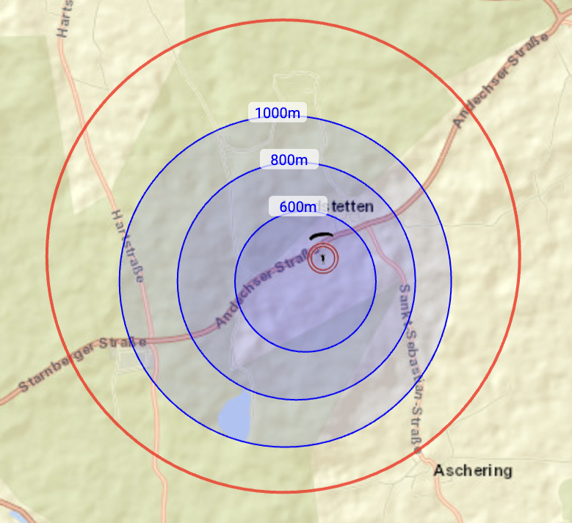

Red circle: Maximum area for canopy flight
For the calculation of the red circle, the mean wind between the ground and the altitude at which the canopy is open (200 m below the opening altitude) is used. If the jumper is within the red circle, they can just reach the landing point (canopy marker) on a long final.
Outermost blue circle: Maximum area to reach the entry point into the pattern.
For the calculation of the blue circle, the mean wind between the entry altitude into the downwind leg and the altitude at which the canopy is open (200 m below the opening altitude) is used. If the jumper is within the blue circle, they can reach the entry point into the pattern.
The smaller blue circles are interpreted in the same way as the largest blue circle, except that lower initial altitudes are used. The gradation is 200 m, 500 m, or 1000 m depending on the altitude difference. A label shows the respective altitude.

Show Jump Run Track:

When [Show Jump Run Track] is activated, the jump run track is calculated and displayed on the map.

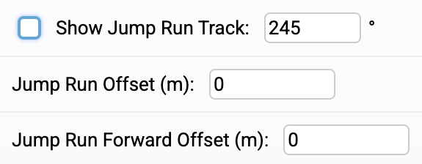

The calculation of the jump run track uses the mean wind between the ground and the opening altitude and is oriented so that “Outbound,” i.e., away from the target, is flown.
The user can rotate the jump run track by entering the approach direction or apply an offset, where positive values shift the jump run track to the right and negative values to the left. The forward offset shifts the jump run track forward (+) or backward (–). A shift is also possible by dragging and dropping the airplane symbol.

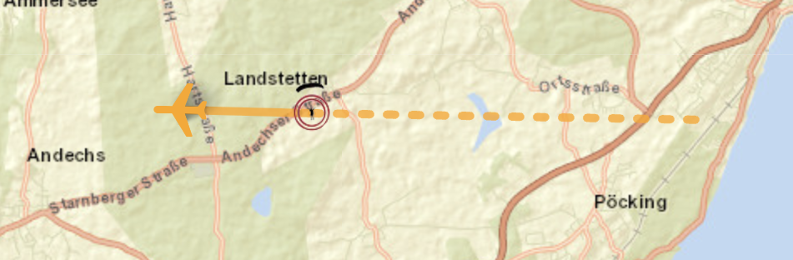
The jump run track is shown on the map as a solid orange line with an airplane at the start. The length of the jump run track corresponds to the drop distance. This is calculated using the values from the [Jump Parameter] menu. The number of jumpers and the time intervals between the jumpers, together with the aircraft speed, result in the drop distance. The aircraft speed is converted from IAS (indicated air speed) to TAS (true air speed) and then, taking into account the wind prevailing at exit altitude, to ground speed. Length and direction of the jump run track are displayed as a tooltip.
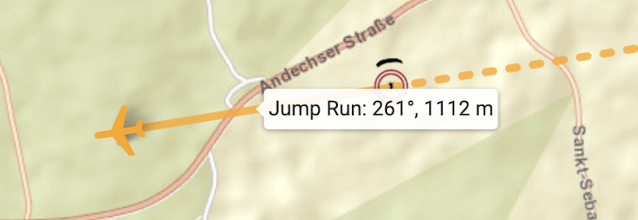
The dashed orange line shows the approach from x-2 minutes. A tooltip shows the approach direction and the length of the approach.

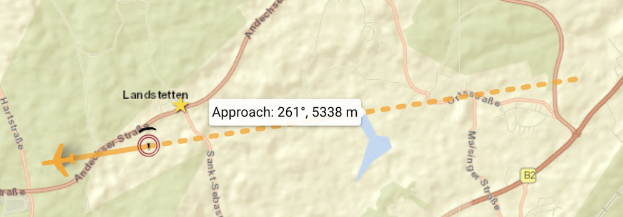

The Jump Run can also be exported as a GPX file, so it can be imported into any other tool (see [Settings] > [Export Jump]).

Show Exit Area:

When [Show Exit Area] is activated, two green circles are displayed on the map.
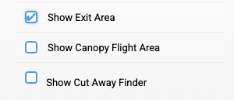

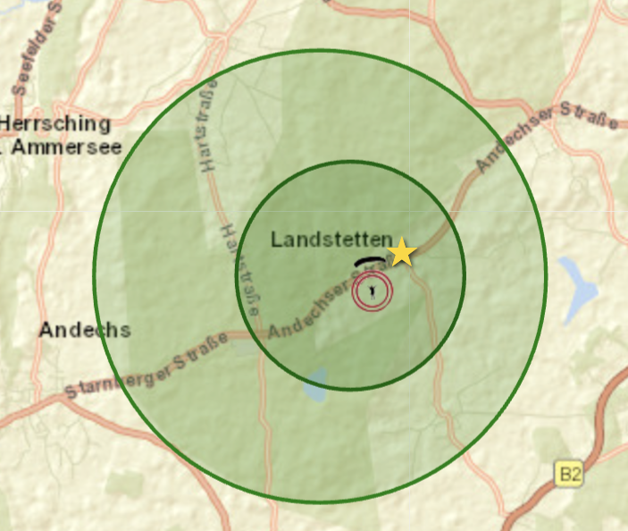
Large circle:
Within this circle, the jumper must be dropped so that, taking throw and drift during freefall into account, they can just barely reach the landing point.
Small circle:
Within this circle, the jumper must be dropped so that, considering throw and drift during freefall, they can reach the entry point into the pattern.
A tooltip displays the freefall parameters, including throw with drift (direction and distance) and the freefall time.

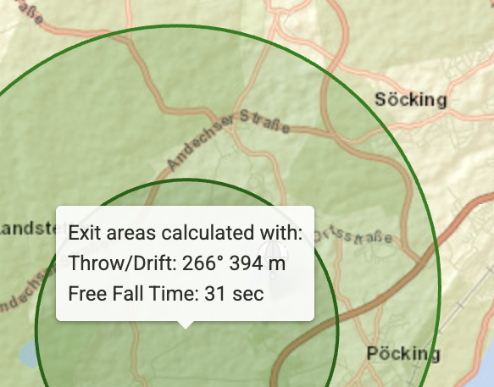
The radii of the green circles correspond to those of the red and blue circles. They are only shifted in direction and distance to account for throw and drift during freefall.

Show Cut Away Finder:

When [Show Cut Away Finder] is activated, you can enter the altitude at which you cut away and the state of the main canopy during descent.

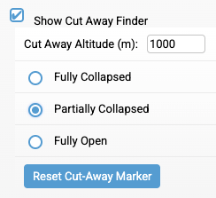

By double-clicking on the map, you can set the point where you cut away. A purple circle will then appear, indicating where the main canopy should be found on the ground.
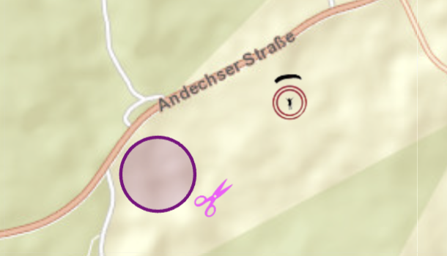

A tooltip provides the detailed values.

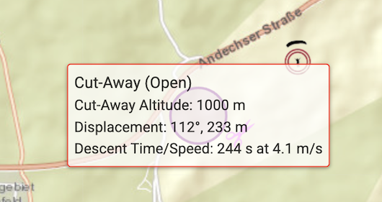

Terrain Clearance:
The Terrain Clearance Test is a useful test for jumps in mountainous areas.
In the field [Min. Clearance (m):], you can set how many meters the jumper should be above the surrounding terrain at a minimum.
The test then checks for the innermost canopy circle whether there is an area where the jumper is expected to be less than the set minimum height above the terrain. This area is then colored as followed:

Farbe | Bedeutung
Red | Clearance < Minimum vertical distance
Orange | Clearance < Minimum vertical distance + 50m
Yellow | Clearance < Minimum vertical distance + 100m
Green | Clearance ≥ Minimum vertical distance + 100m

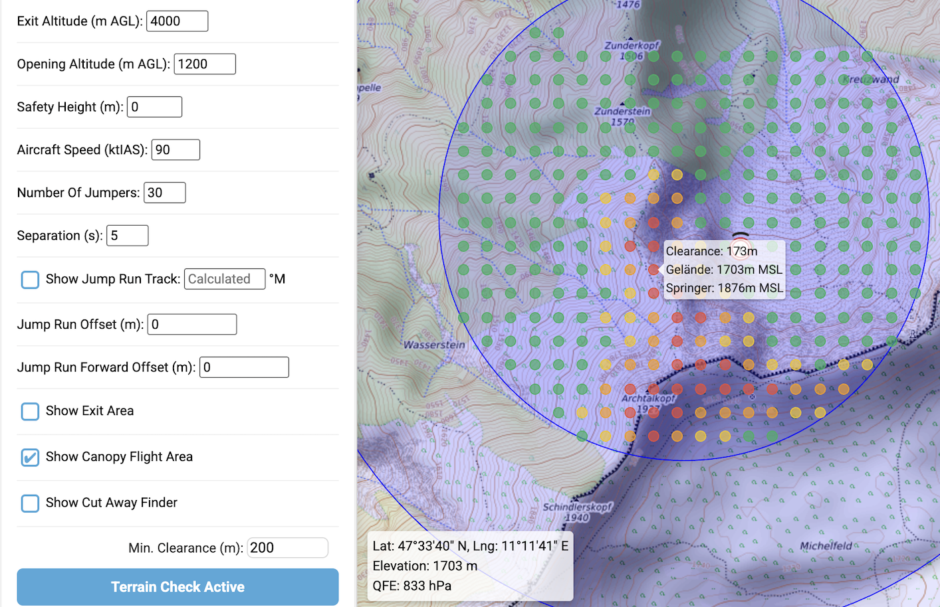

HARP Manager

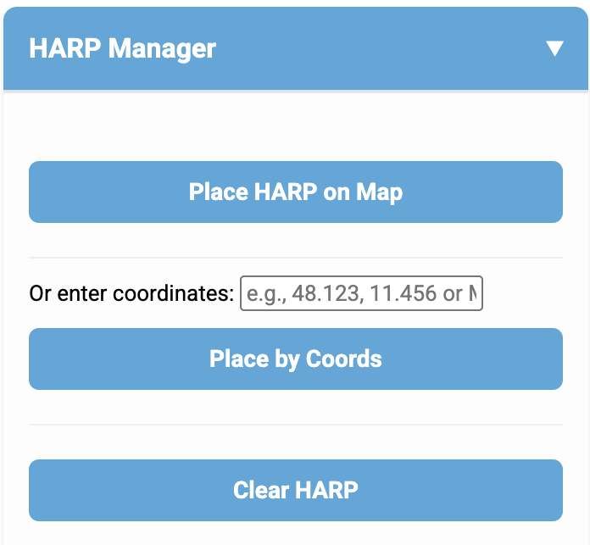

In the [HARP Manager] menu, you can interactively set a HARP position. If you activate [Place HARP on Map], you can set a green point with a popup showing coordinates, elevation and QFE at the desired HARP position with a simple click on the map.
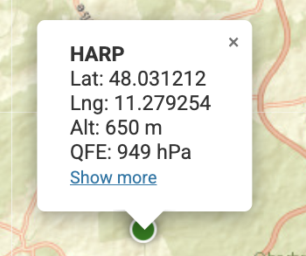
Alternatively, you can enter the HARP coordinates in MGRS or decimal degrees.
[Clear HARP] removes the set HARP from the map.
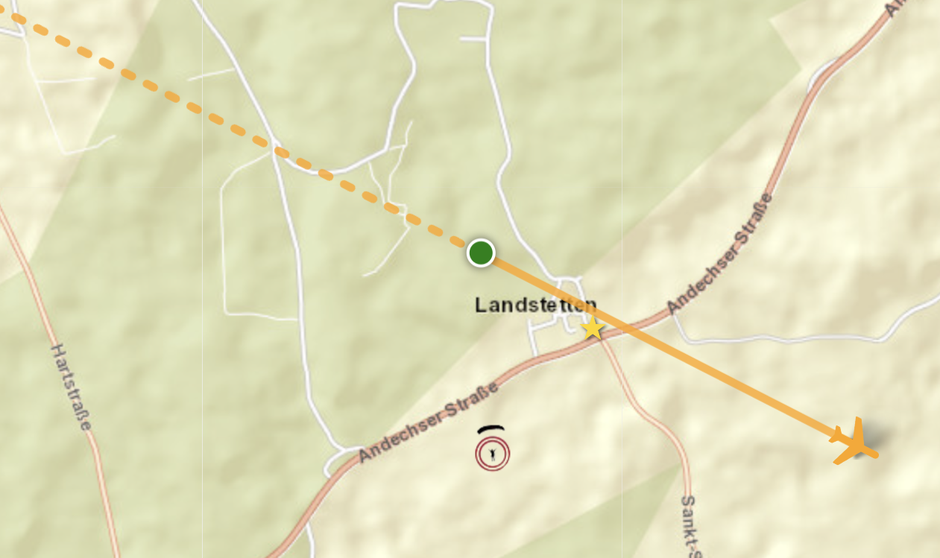
The Jump Run Track is then automatically shifted so that the HARP becomes the new reference point.

As with the drop zone marker (see 2.1.4), the QFE shown at the HARP can also be calibrated by tapping it against a measured altitude. The QFE at the HARP is correctly converted barometrically from the drop zone marker’s terrain elevation to the HARP’s elevation.

Ensembles

In the [Ensemble] menu, you can compare the different weather forecast models available at the DIP.
The exit circles for the selected models are drawn on the map for comparison. A tooltip shows the mean wind in the altitude range between opening and ground.

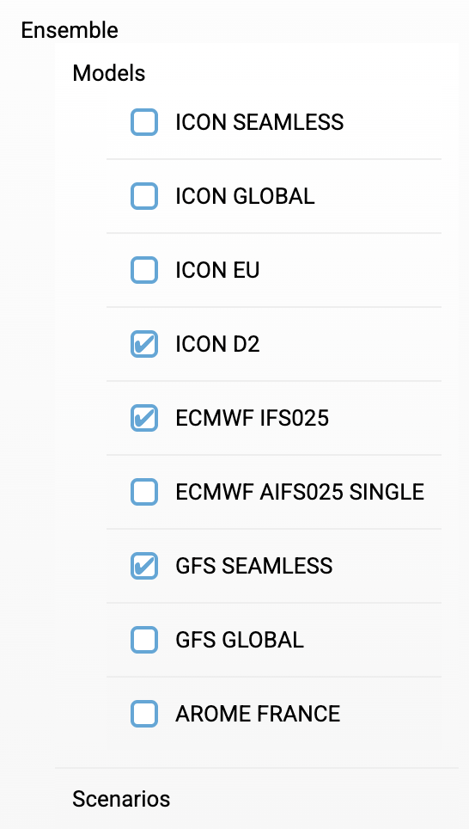

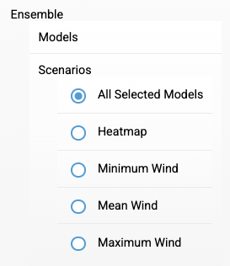
In the [Scenarios] menu item, you can select what should be displayed on the map.
With “All Selected Models,” a circle is drawn for each selected model.

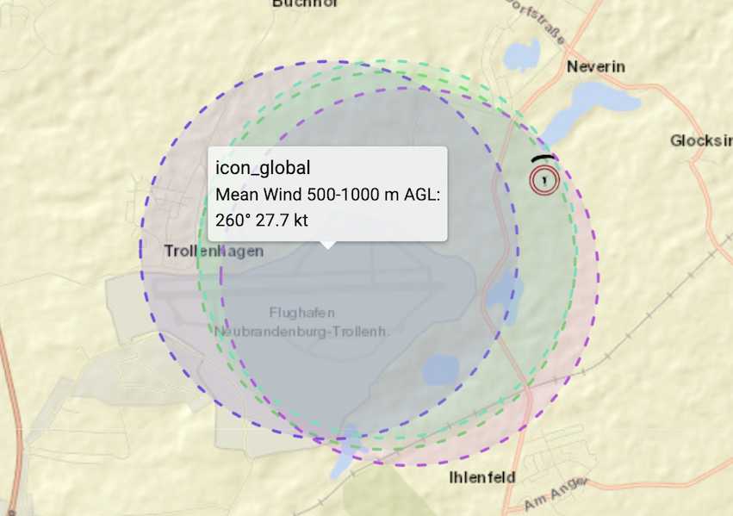

“Heatmap” plots a colored area on the map, which is interpreted as follows:
- Green: the area covered by all selected models
- Yellow: the area where half of the models overlap
- Red: the area covered by only one model

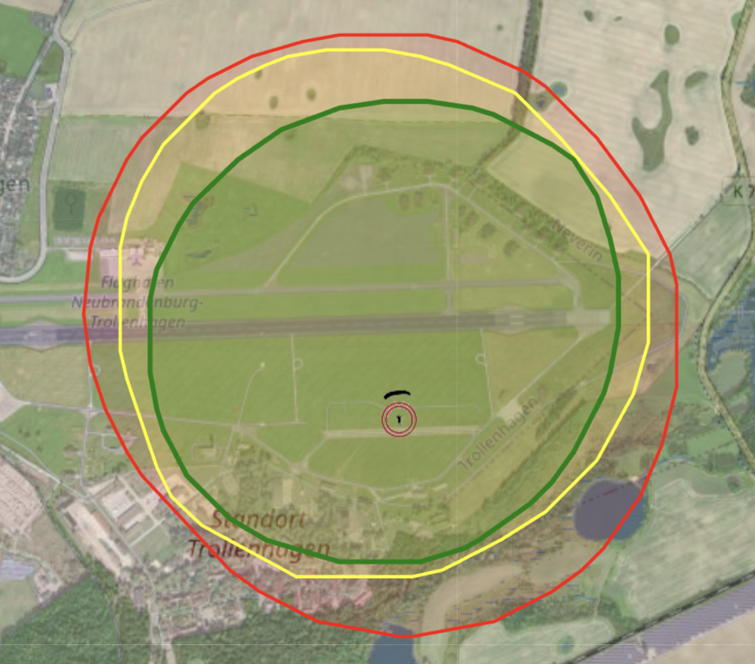

For the other options “Minimum Wind,” “Mean Wind,” and “Maximum Wind,” only one circle is displayed for the lowest, average, and highest wind drift, respectively.
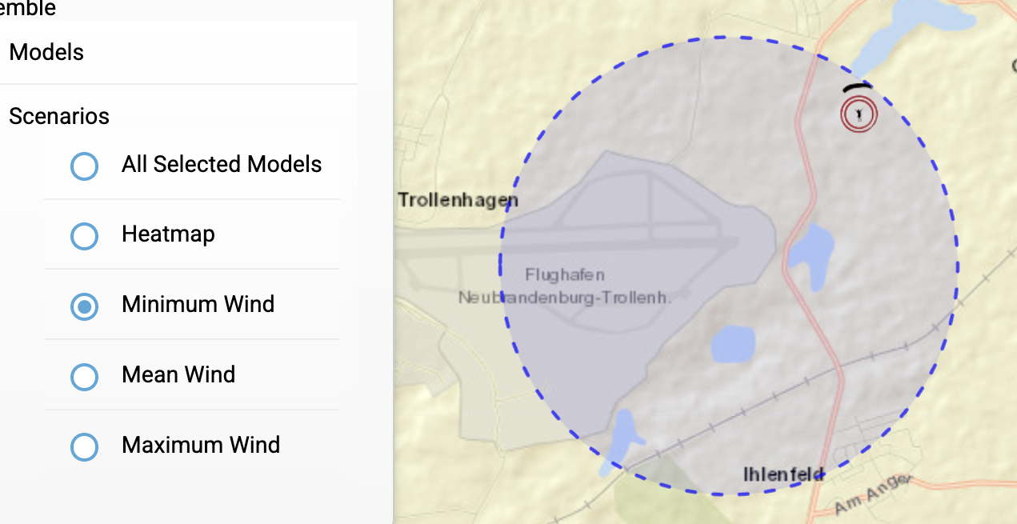

Jumpmaster Panel

The Jumpmaster Panel in the web version includes all functions related to live location display.
To use the live tracking functions, GPS reception is required.

ADSB Tracker

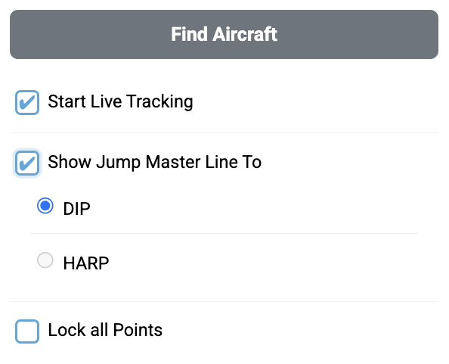

When you click on [Find Aircraft], DZ-Master searches for aircraft within a 15 nm radius.
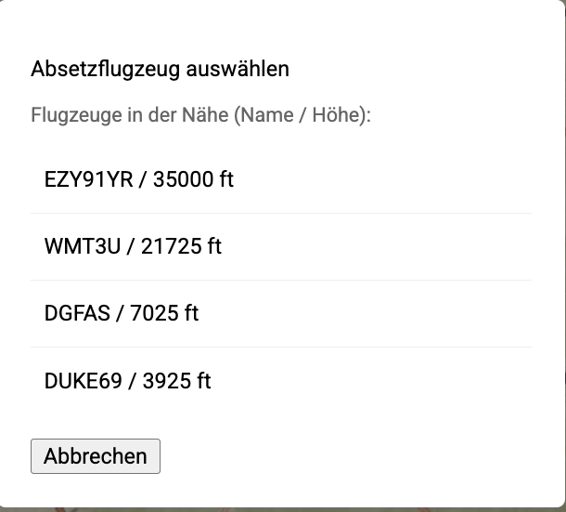
You can then select the drop aircraft and view its flight data and track on the map. The display is updated every 10 seconds.

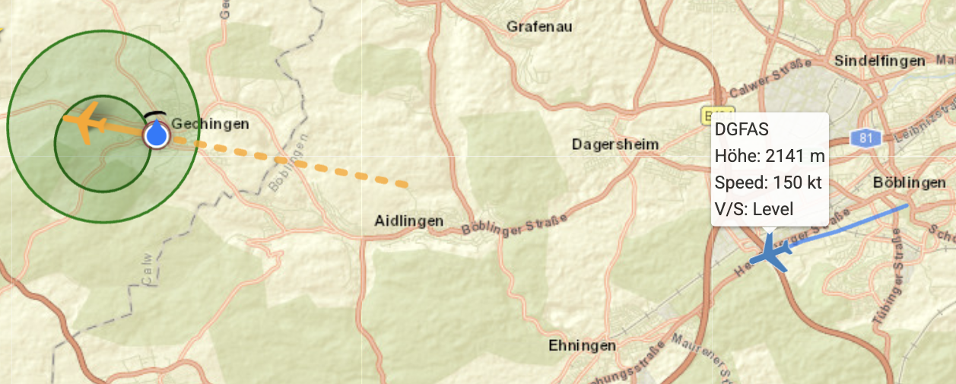

Live Tracking

When [Start Live Tracking] is activated, a blue dot with a direction arrow appears at the current position, and a display panel appears at the top left of the map (in the app) or in the sidebar (in the web version). Data that is not available, e.g., because there is no GPS signal, is shown as N/A.

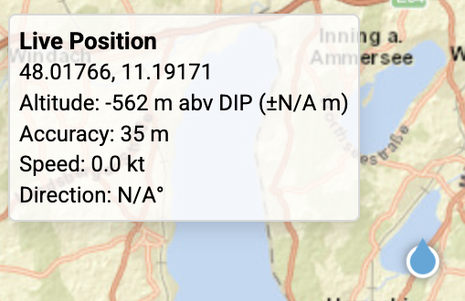

Note: The live tracking panel (see illustration above) only appears in the DZ-Master app and is not available in the web application.

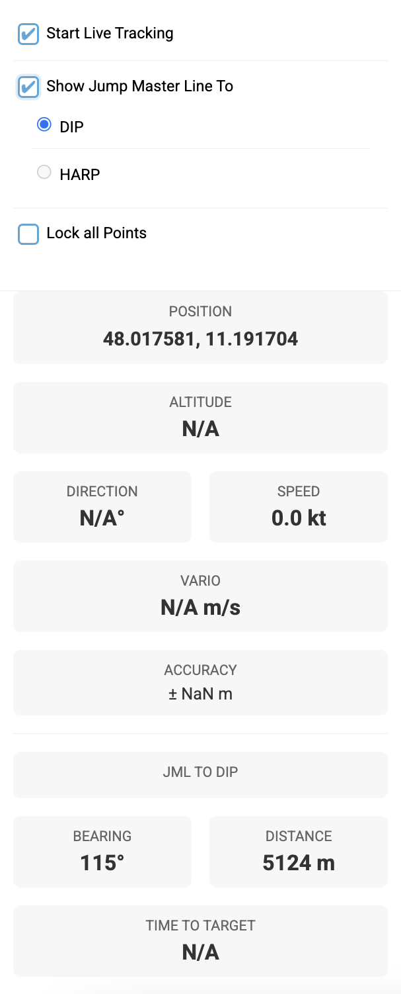

Jump Master Lines

When [Show Jump Master Line To] is activated, a new submenu opens.

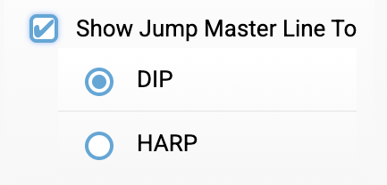

A blue dashed line is then displayed on the map, either to the DIP or to the HARP. The display panel automatically expands to show direction, distance, and time to the DIP/HARP.

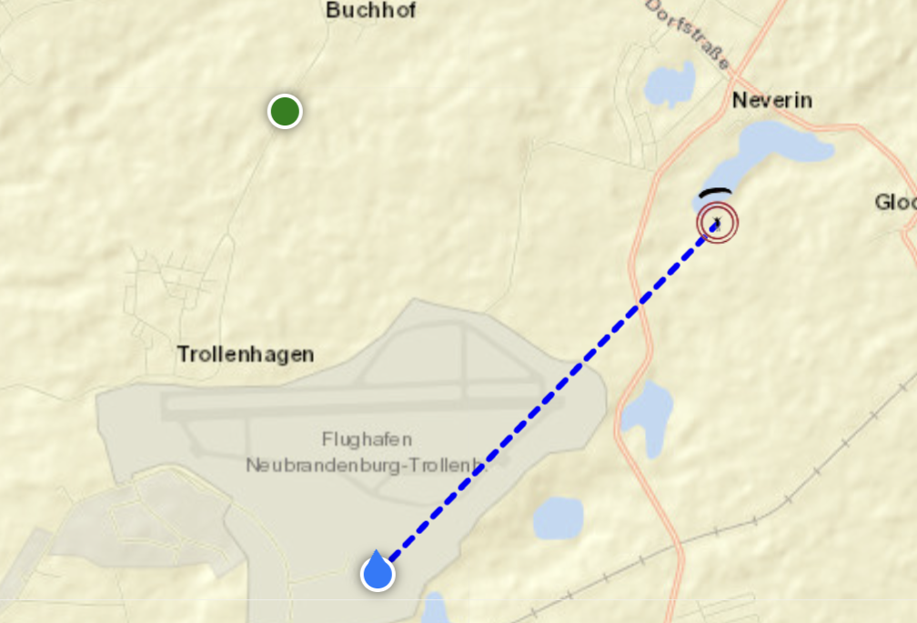 | 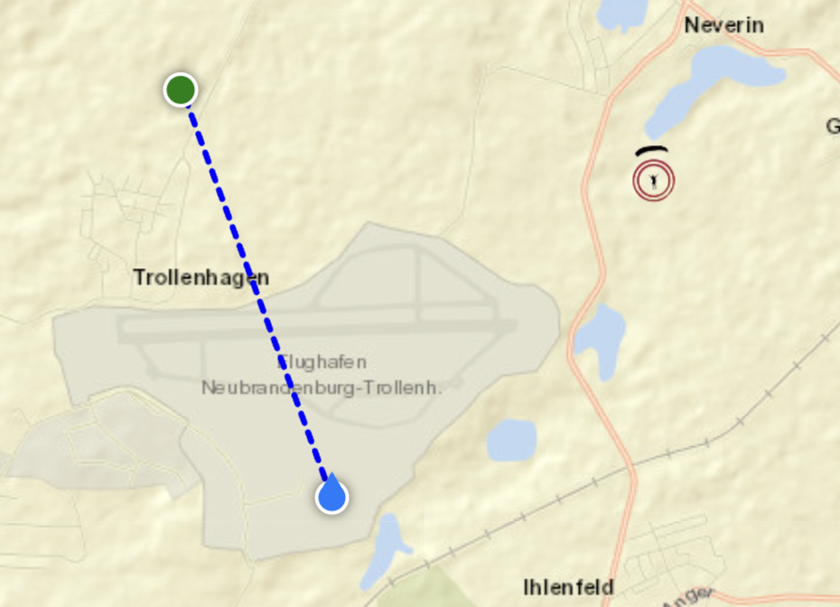

“Lock all Points” offers the option to lock the interactivity of DIP, HARP, Jump Run Track, Cut Away Finder, and drawn lines/circles/points to prevent accidental movement.

Map Orientation

When [Start Live Tracking] is activated, a map orientation toggle button appears in the top right corner of the map.

The button switches between two modes:

N Up – The map is oriented with North at the top (default).
HDG – The map rotates automatically to match the current direction of travel (Heading Up). The active mode is highlighted in blue.
At speeds below 2.5 m/s the map orientation is frozen to avoid erratic rotation.

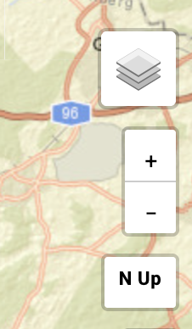 | 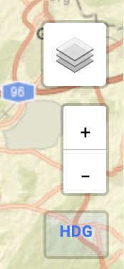

If the map is moved manually while in Heading Up mode, rotation pauses for 10 seconds before resuming automatically.

When Live Tracking is stopped, the map resets to North Up.

Note: Map rotation is only available in the DZ-Master app and is not available in the web application.

Under [Settings] > [Map Settings] > “Keep map fixed to North Up,” this behavior can be set permanently: map rotation and Heading Up mode are then fully disabled, the map always stays North Up, and the toggle button is hidden.

Auto Follow

When [Start Live Tracking] is activated, the map automatically centers on the current live position as it moves.

If the map is panned manually, Auto Follow pauses for 30 seconds. A button labeled ⊙ Follow appears in the bottom right corner of the map. Tapping it immediately recenters the map on the current live position and resumes Auto Follow without waiting for the timeout.

Note: Auto Follow is only available in the DZ-Master app and is not available in the web application.

Under [Settings] > [Map Settings] > “Auto-follow during live tracking,” Auto Follow can be switched on or off entirely if a freely movable map is preferred.

Dashboard

The dashboard is only available in the app version of DZ-Master. Depending on the selection, it serves the jumper during the jump or the jumpmaster with live data.

Jumper

The Jumper Dashboard displays all values relevant to the jumper during canopy flight:
SPEED | Jumper’s speed in kt
DIRECTION | Flight direction (track) of the jumper
ALTITUDE | Altitude above the DIP
RANGE | Estimated range based on the current glide ratio
GLIDE TO DIP | Required glide ratio to the DIP
GLIDE RATIO | Current glide ratio
BEARING TO DIP | Bearing to the DIP
DISTANCE TO DIP | Distance to the DIP

The values GLIDE TO DIP and RANGE turn red if, based on the current values, the DIP can no longer be reached.

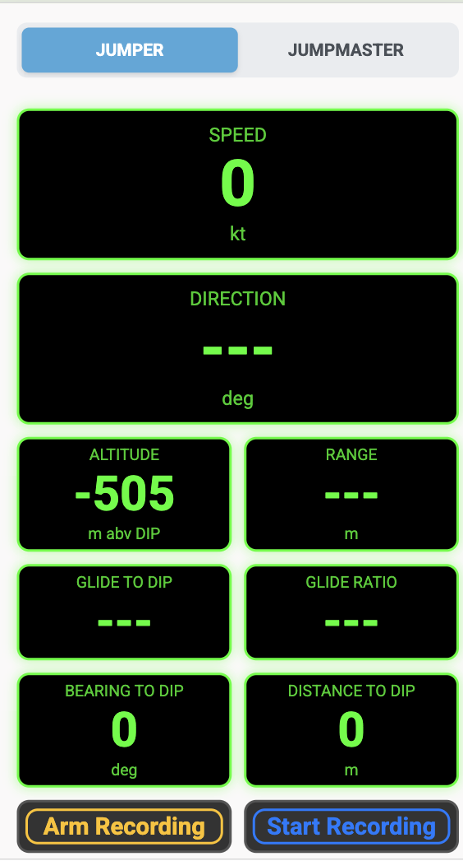
The [Arm Recording] button arms the system. Based on the phone’s sensors, the exit is automatically detected, and track recording starts. It also automatically ends when the system detects landing.
[Start Recording] immediately starts track recording and must be actively stopped.
Before starting a recording, the DIP should be set to the actual drop zone. All heights above ground (AGL) refer to the terrain elevation at the DIP – both during the jump and later when the track is loaded. In addition to the DIP, the saved track also contains the actual landing point as a waypoint.
If a meaningful calculation of GLIDE TO DIP or RANGE is not possible, a status text is shown instead of a numeric value: “no GPS altitude” (no GPS altitude available), “climbing” (the jumper is climbing instead of descending), “descent rate too low” (the descent rate is below a meaningful threshold), or “no ground speed” (no valid speed value available).

Jumpmaster

The Jumpmaster Dashboard contains all information relevant for the jump master.
The values BEARING, DISTANCE, and TIME TO TARGET are only displayed if the user has activated “Show Jump Master Line To.”
Navigation to the HARP can only be selected if a HARP has also been set on the map.

POSITION | Coordinates of the current position in the selected format
ALTITUDE | Altitude above the DIP
DIRECTION | Flight direction (track)
SPEED | Speed in kt
VARIO | Climb/descent rate
ACCURACY | GPS accuracy
BEARING | Bearing to the DIP/HARP
DISTANCE | Distance to the DIP/HARP
TIME TO TARGET | Estimated time to reach the DIP/HARP based on current speed

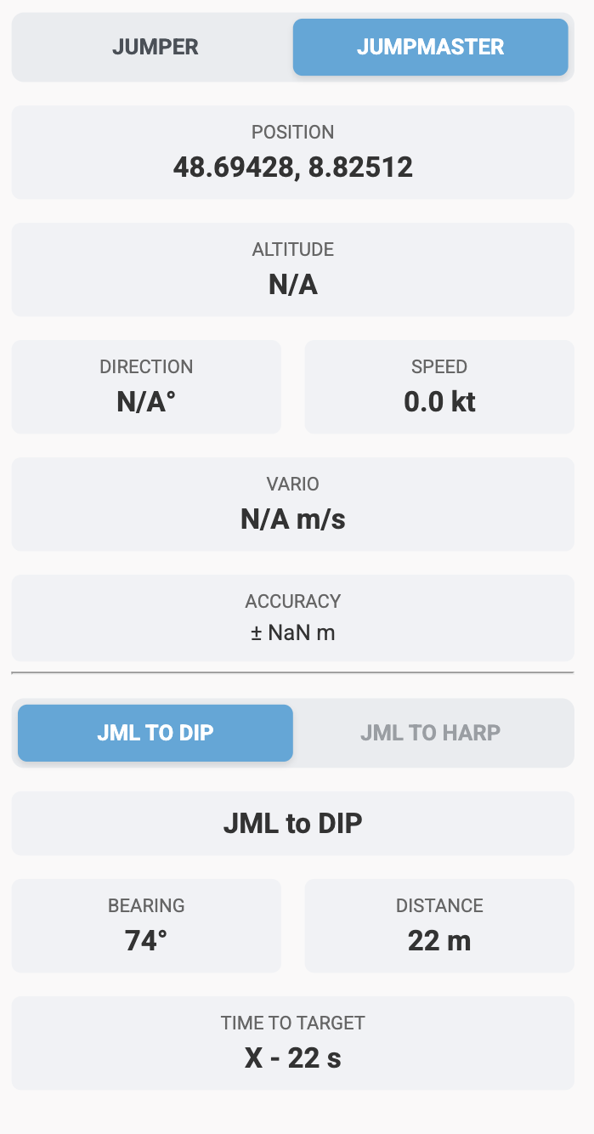

Search Panel

The Search Panel allows you to search for locations, coordinates, and drop zones.

Locations

Coordinates can be entered as decimal coordinates or MGRS.
The coordinate then appears under “Results” and the DIP can be moved there by clicking on the search result.
You can also search by place names.
The selected position can also be saved as a favorite using the “star button.” You can also assign your own name to the favorite.
To remove a favorite from the list, click on the star; to delete the location completely, click on the cross.
You can also save the current coordinate as a favorite.
One location can be stored as HomeDZ by clicking on the home button. If location service is not available the app centers by default to the home DZ.
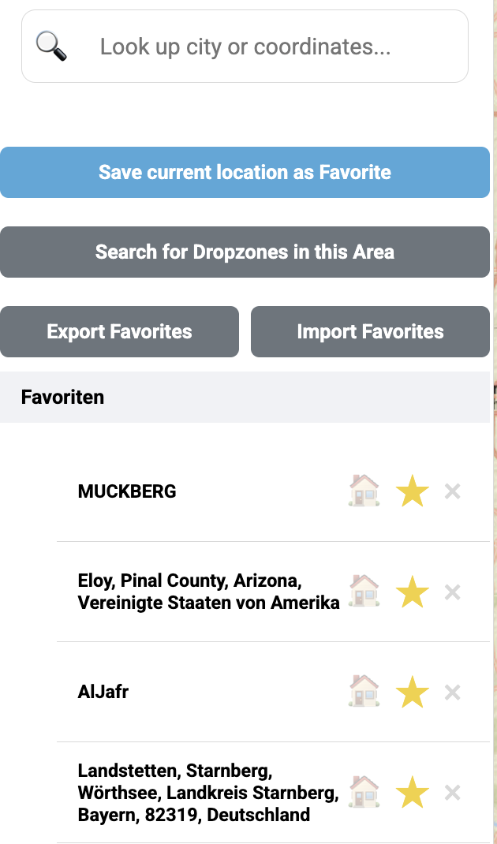

The number of “Recent Searches” is limited to five. However, you can save an unlimited number of favorites.
Locations saved as favorites are displayed with a star symbol on the map.

The “Export Favorites” and “Import Favorites” buttons above the favorites list can be used to save the entire favorites list to a file, or to load it again on another device. When exporting, the file is stored under Documents/DZMaster in the app, or downloaded in the browser.

Dropzones

By clicking the “Search for dropzones in this area” button, drop zones in the selected map section are displayed with a small parachute symbol.
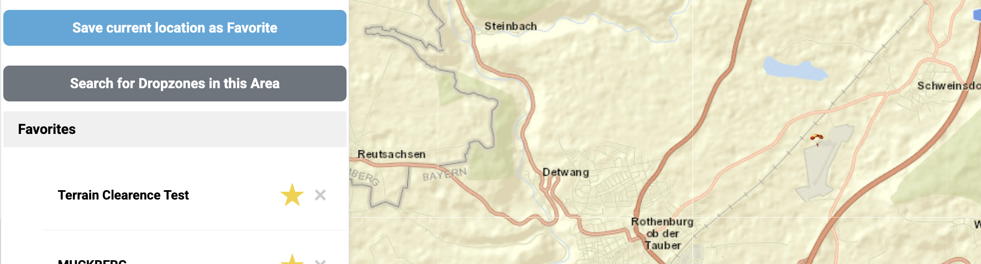

Settings Panel

In the Settings Panel, various types of settings can be made.

Units

Under “Units,” you can set the units and formats exactly as you wish.

Reference level | AGL | AMSL
Altitude | m | ft
Temperature | °C | F
Speed | kt | km/h | m/s | mph | bft
Time zone | Z | loc
Coordinate format | MGRS | Dezimalgrad | DD mm ss

Download Files

Under Download File, weather data can be downloaded in various formats as an ASCII file, so that it can be used in other tools.
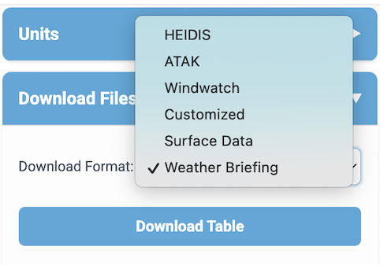

If Weather Briefing is selected, a weather briefing for the current day is created in a new browser tab. It includes surface data and upper air data up to the altitude set as the “Upper limit” for mean wind.

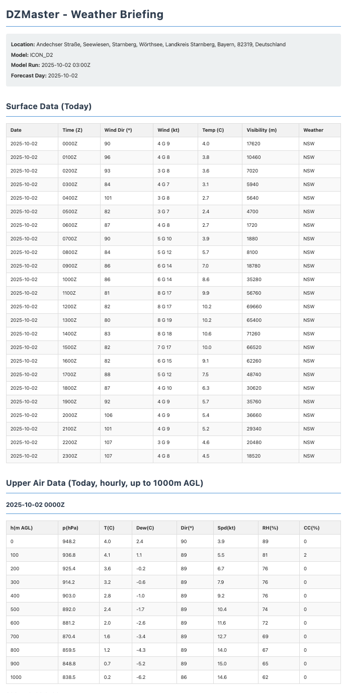

Export Jump

Under [Export Jump], the planned jump and the elements drawn on the map can be exported as a GPX file, e.g. to transfer them to a GPS device or watch or to load them into another tool. Under “Include”, select what the file should contain:
“Jump Run & Exit”: the Jump Run Track with the waypoints X-2, HARP and LAST OUT at exit altitude.
“Landing Pattern”: the landing pattern with the DIP as a waypoint; the corner points carry the configured altitudes of the individual legs.
“Exit Area (Green)”: the green exit circles at exit altitude.
“Canopy Range (Red/Blue)”: the red maximum canopy range and the blue circles of the ideal position at their respective altitudes.
“Drawn Elements (Map)”: the elements drawn with the measuring and drawing tool. Polylines and circles are exported as tracks whose name contains the total length or the radius (e.g. “Line 1 (∑ 2.51 km)”, “Circle 1 (r 850 m)”); bearing and length of each segment are given in the track description. Point markers are exported as waypoints “Marker 1”, “Marker 2” …, labels as waypoints named with the entered text. Drawn elements carry no altitude.
“Merge for Devices (Single Color)” combines all tracks into one single track. This is intended for devices such as Garmin or Suunto watches; the names and colors of the individual tracks are lost, the waypoints are kept.
[Export GPX] creates the file. The jump requires weather data and a DIP. If only drawn elements are exported, neither is needed; the file is then named “Map_Drawings_<date_time>.gpx”, otherwise “Jump_Plan_<date_time>.gpx”. In the mobile app it is saved in the “DZMaster” folder under Documents.

Map Settings

The [Map Settings] menu contains two new checkboxes: “Keep map fixed to North Up” permanently disables map rotation and Heading Up mode (see 2.4.5 Map Orientation). “Auto-follow during live tracking” switches automatic centering of the map on the current live position (see 2.4.6 Auto Follow) on or off entirely.
To be prepared for situations where you have no internet connection (e.g., in an airplane), map tiles are stored locally.
This happens automatically for a radius of 5 km around the DIP. When moving the map, the visible map tiles in the displayed zoom level are also stored.
You can also specifically download maps via the [Cache Settings] menu.
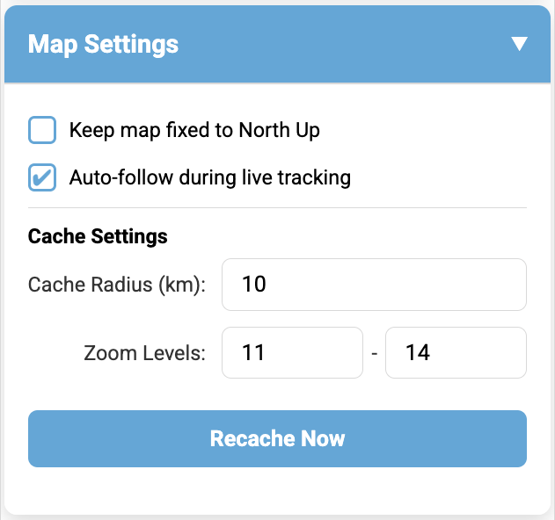

The user can select the radius around the DIP as well as the desired zoom levels and then start the download by clicking “Recache Now.”

Historical Date

Under [Historical Data], you can select a date in the past. The data for the selected day will then be loaded and can be displayed/used.
Clicking [Clear] resets the date to the current one.
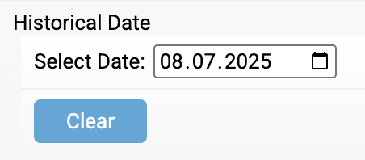

Import

The [Import] section loads files into the app: tracks and vertical profiles. Each area has its own file selection and its own button for removing the file.
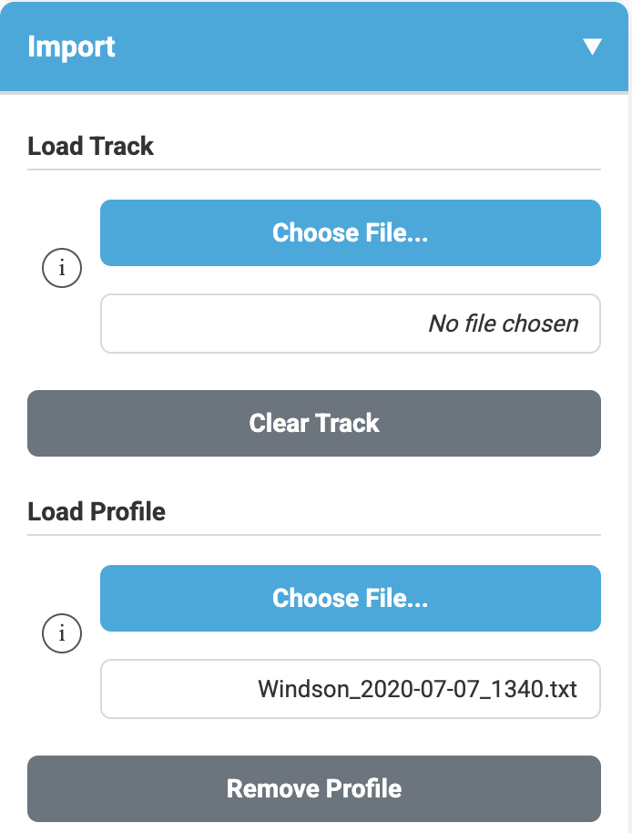

Load Track

Under [Load Track], you can load a track in the common GPX format or CSV format (FlySight tracker). This can be deleted again by clicking [Clear].
KML files also can be displayed the same way as described above.

The track is then displayed on the map. According to the altitude AGL, a color gradient from green (3000 m AGL) to red (ground) is shown.
The exact values (altitude AGL, ground speed, and sink rate) are displayed via a tooltip.

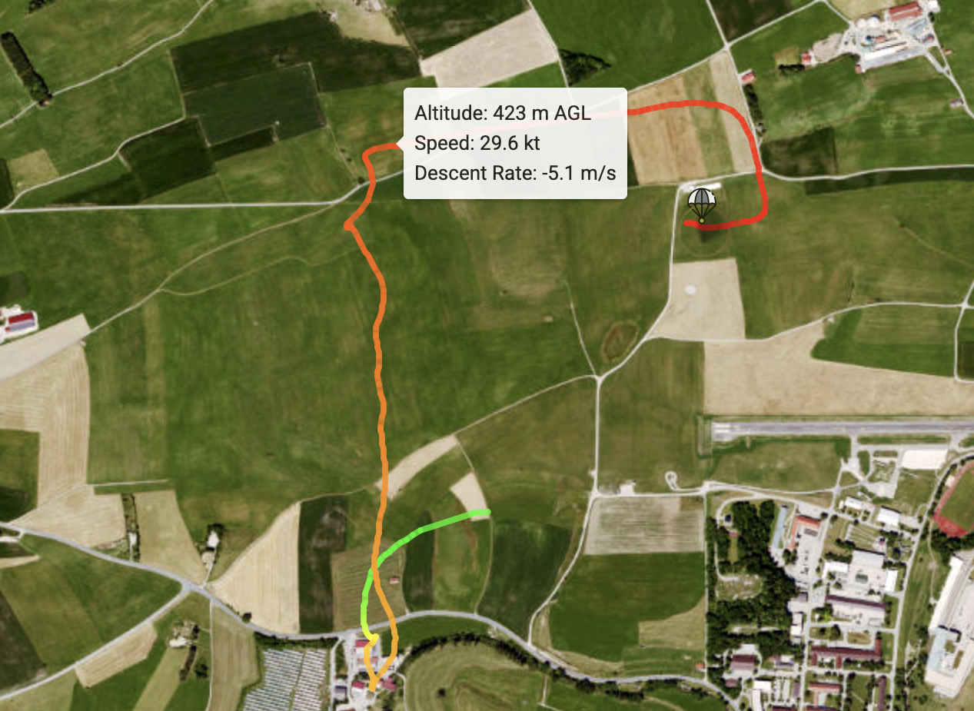

When loading a track, the map is automatically centered on the track and the time is set to the date/time group contained in the track. If the file contains a DIP waypoint (e.g. tracks recorded with DZMaster), the DIP marker is set there; otherwise it is set to the last track point.

If the saved DIP is more than 3 km away from the landing point or its terrain elevation differs by more than 50 m, the app asks whether the DIP or the landing point should be used as the reference for AGL heights. The landing point is usually the right choice: a DIP that differs this much usually means it was not set to the drop zone before the jump.

Load Profile

Under [Load Profile], a measured or exported vertical profile, the “own profile”, can be loaded instead of model data. Supported are text files from Windsond and Graw radiosondes (GRAWMET export, wind in m/s or knots) and TEMP exports from NinJo. The profile fully replaces the model data: the surface values are taken from the profile as well, no model data is mixed in.

A DIP must be set before loading. After choosing the file via [Choose File...], a dialog opens:
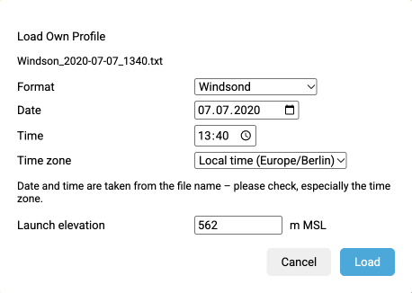
Format, date and time are prefilled from the file content and file name and should be checked. For Graw files, implausible heights at the start of the profile and missing pressure values are reconstructed from pressure, height and temperature. The time zone must always be selected (UTC or local time of the device), as exports are not consistent in this respect. For Windsond data and older Graw exports (wind in knots), whose heights refer to the launch site, the launch elevation is requested as well; it is prefilled with the terrain elevation at the DIP. If the profile contains no valid wind within 50 m above ground, the dialog also asks for the surface wind.

After [Load], the entry [★ Own Profile] is selected in the model dropdown. Weather table, mean wind, Windspinne and jump calculation then use the profile. The info button shows file, format, valid time and the comparison of the ground elevations:
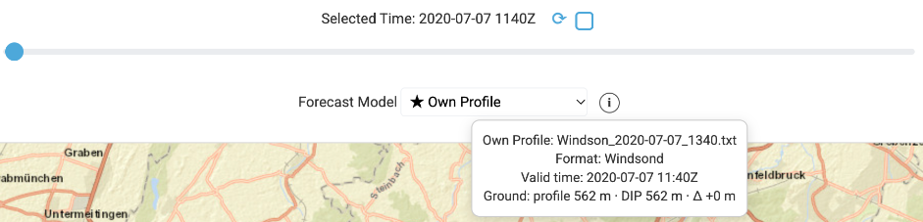
As a profile describes a single point in time, the time slider is locked, autoupdate is switched off and the meteogram is hidden. Ensembles continue to use model data only.

The profile is transferred to the DIP, keeping the heights above ground. If the DIP is moved, the profile stays active and is transferred to the new terrain elevation. If the ground elevation of the profile differs from the terrain elevation at the DIP by 100 m or more, a warning appears; the calculation continues anyway. Use the values with caution in this case.

[Remove Profile] removes the profile and reloads the last selected model. Alternatively, a model can be selected in the dropdown at any time; the profile then remains available in the dropdown until it is removed. The profile is not saved and is gone after reloading the page or restarting the app.

App Management

In App Management, all settings can be reset to default and the map cache can be cleared.
There is also the possibility to switch to dark mode. Colors are turned dark to avoid dazzle effects.

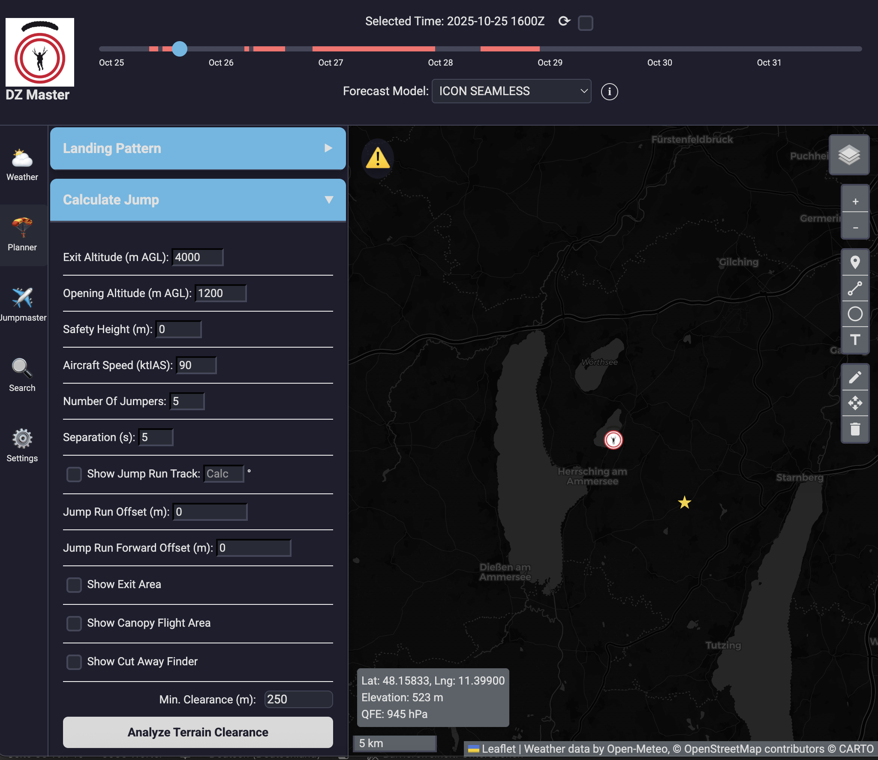

Alerts

Here, configurable alerts can be set.

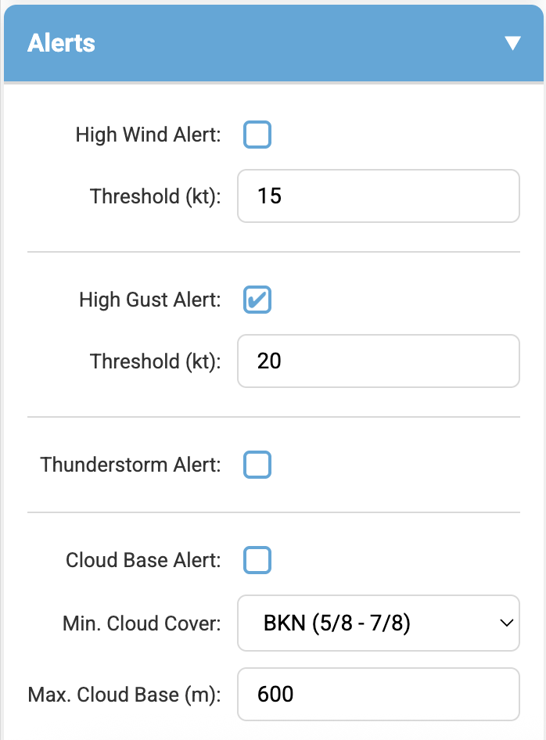

If a tick is set for an alert criterion, the time slider will turn red as soon as the criterion is met.

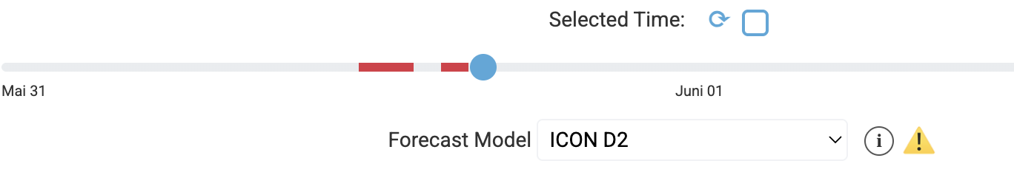

Additionally, a warning sign will appear to the right of the model info button.
Clicking on the sign opens a detailed explanation, showing which alerts are active and when the event is expected to first occur.

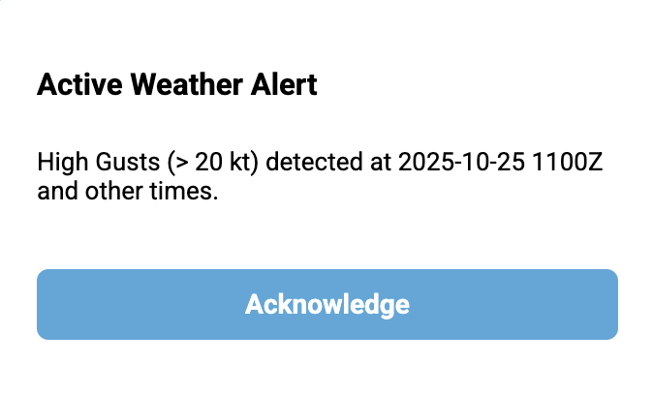

Notes and Warnings

The provided weather data may be inaccurate or incomplete.
Each user is responsible for their own decisions and actions.
DZ-Master is intended solely as an aid and should not be used as the sole basis for decision-making.
It is strongly recommended to critically review all information and consult additional sources.
Legal requirements and safety regulations must also be observed.

